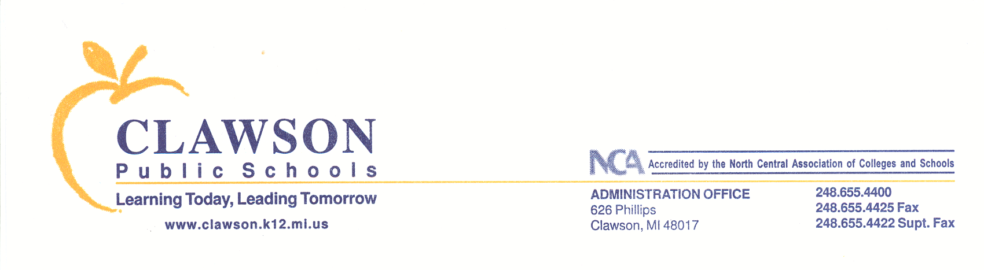

248.655.4422 Fax

August 2019

CLAWSON PUBLIC SCHOOLS
Advisory to All Parents
Integrated Pest Management Program
2019 Notification

Dear Parent/Guardian:
Clawson Public Schools has adopted an Integrated Pest Management program. Inherent with this are the District’s efforts to reduce pesticide use as much as possible. While it may occasionally be necessary to apply a pesticide, this program does not rely on routine pesticide applications to resolve problems. We use various techniques such as habitat alteration, sanitation, mechanical means, exclusion, etc. to prevent pest from becoming a problem.
As required by Michigan law, you will receive advanced notice of non-emergency application of a pesticide (insecticide, fungicide, or herbicide), other than bait or gel formulation, which is made to the school, school grounds, or buildings. This advance notice of a pesticide application will be given 48 hours before the application by the following two methods:
- Posting at the primary entrances to your child’s school. The entrances that will be posted are the main entrance and those that have a sidewalk that leads directly to a parking lot.
- Posting in the common area located by the main office of the school.
Please note that notification is not given for use of sanitizers, germicides, disinfectants or anti-microbial cleaners. In certain emergencies, such as an infestation of stinging insects, pesticides may be applied without prior notice to prevent injury to students, but you will be promptly notified following any such application, via the two posting methods identified (above).
You may review the school’s Integrated Pest Management program and records of any pesticide application upon request by contacting Mr. Jamie Stottlemyer at james.stottlemyer@clawsonschools.org
Parents or guardians of children attending the school are also entitled to receive the advance notice of a pesticide application, other than a bait or gel formulation, by first class United States mail postmarked at least 3 days before the application, if they so request. If you would like to be notified by mail please email james.stottlemyer@clawsonschools.org. Provide your name, mailing address, contact phone number and the school(s) your child or children attend.

